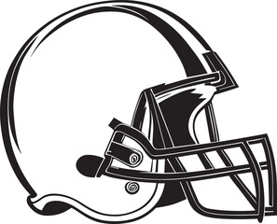

Inaugural Bandon Crossings Super Bowl Tournament
Passholders Only
Entry Fee $60 Per Person
If you wear a jersey $55
Teams: Teams and pairings will be decided by the coaches, Matt and Jim. You will sign up individually and get drafted onto either the NFC or AFC team. Parings will be made when all players have been drafted.
Includes: Green fees, cart, prize fund, range balls and lunch after golf
Prizes: KP on all par 3s
Optional: Entry into football square sheet. $2 per square with 100 available
Sunday February 11th, 2024
10:00 Shotgun

Format: 2-person match play with 3 total points available for the front 9, back 9, and overall. Front 9 Scramble and Back 9 Chapman. Chapman format is both players hit drives. Each player takes their 2nd shot from the end of the other player’s drive. The best of the 2nd shots is selected to continue playing the hole. From the best of the 2nd shot, the partners play alternating shots to the hole. The player whose second shot was picked up, plays the third shot, hitting the best of the 2nd shot ball.
TWO DRIVE MINIMUM PER PLAYER

FOUR DRIVE MINIMUM PER PLAYER.

Official Entry Form for Bandon Crossings Super Bowl Tournament Sunday, February 11, 2024
Name:___________________________________________ GHIN#___________________________
email:_____________________________________________________ Phone:___________________________

Players without an official USGA handicap will have to play to a zero HDCP.
Please mail completed entry forms to: Bandon Crossings Golf Course 87530 Dew Valley Lane, Bandon, OR 97411
Questions? Call 541-347-3232 email: - jim@bandoncrossings.com
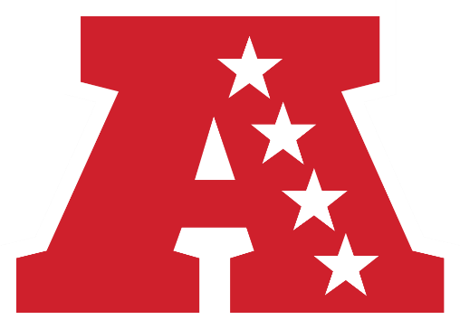
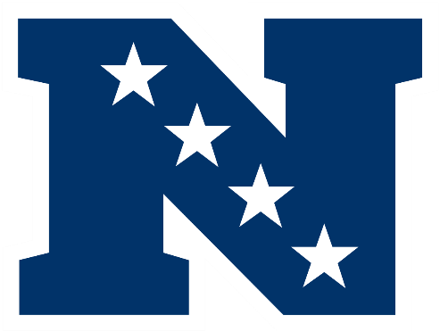
email: - matt@bandoncrossings.com

