FILL THE SHELVES FUNDRAISER
Monday January 1st, 2024
10:00 Shotgun
Proceeds to Benefit Local Food Banks
Format: Shamble is like a scramble. Both players tee off then select the best tee shot. Both players then play their next shot from best tee-shot. From this point both players play their own ball into the hole. Best net score equals team score.
FOUR DRIVE MINIMUM PER PLAYER.
Entry Fee $70 Per Person
Crossings Pass-Holders $55
Includes: Green fees, cart, prize fund, range balls and lunch after golf
Prizes: Net division only. KP on all par 3
Long drive, 1-each for men & ladies.
Optional: $40 per team honeypot. Net division only. Mulligans available for purchase, two for $20 with four maximum per team. Proceeds from mulligans will be donated to food shelters.
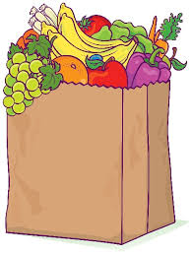

Official Entry Form for Fill the Shelves Golf FUNDRAISER Monday , January 1, 2024
Name:___________________________________________ GHIN#___________________________
email:_____________________________________________________ Phone:___________________________
Team Name:__________________________________________ (optional)
Name:___________________________________________ GHIN#___________________________
Player’s without official USGA handicap will have to play to a zero HDCP. Last Year $1500 was donated to two area food banks
Please mail completed entry forms to: Bandon Crossings Golf Course 87530 Dew Valley Lane, Bandon, OR 97411
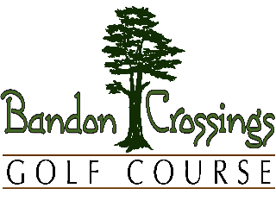
Questions? Call 541-347-3232 email: - jim@bandoncrossings.com
email: - matt@bandoncrossings.com

