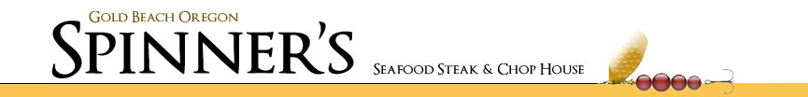
PRESENTS
BANDON CITY BEST BALL
JUNE 8-9 2019
FORMAT: TWO-PERSON BEST BALL, 36-HOLE STROKE PLAY.
GROSS AND NET DIVISIONS, OPEN-SENIOR & LADIES DIVISIONS
ENTRY FEE: $300 PER TEAM
INCLUDES: Saturday & Sunday green fee, range balls, Lunch Sunday followed by awards ceremony.
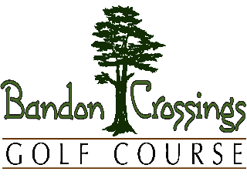
OTHER:
* Gross & Net divisions.
* Both players must be 50 years of age to qualify for Senior division.
* Optional daily skins game, $40 per team per day.
* Teams will be repaired after round 1 based on Saturday score.
*Maximum team HDCP differential 10 strokes
*Maximum Individual HDCP of 36 Men, 40 ladies.
* USGA handicap required. Or play to a zero HDCP
*Carts Additional $12 per person per day.

Bandon City Best Ball Official Entry Form *Sat-Sun June 8-9 2019
Name: _____________________________________ Golf Course: ____________________
Address: __________________________City: ______________ Zip_________ GHIN: ___________ PHONE: _______________
Name: _____________________________________ Golf Course: ______________________
Address: ___________________________City: ______________ Zip_________ GHIN: _________
FIRST TEE TIME: SATURDAY 9:00, SUNDAY 8:00
Carts additional $12 per day per person
ENTRY DEADLINE-June 1, 2019
*Make Check payable Bandon Crossings 87530 Dew Valley Lane Bandon, OR 97411
Register online @ bandoncrossings.com
* For more information contact Crossings @ 541-347-3232

